Implementation of Web Page Rank Algorithm
Refernce : http://codispatch.blogspot.com/2015/12/java-program-implement-google-page-rank-algorithm.html

When you go and type some keywords in Google Search Engine a list of Web Pages will be displayed ,but how does the search engine know which page to be shown first to the user ? To solve this problem a algorithm called PageRank was developed at Stanford university by Larry Page and Sergey Brin in 1996.The PageRank Algorithm uses probabilistic distribution to calculate rank of a Web page and using this rank display the search results to the user. The Pagerank is recalculated every time the search engine crawls the web.
To calculate PageRank for the n Webpages ,First we initialise all Webpages with equal page rank of 1/n each.Then Step by Step we calculate Page Rank for each Webpage one after the other.

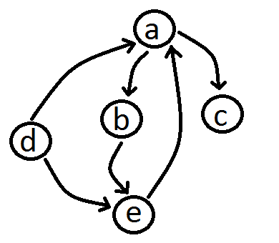
There are 5 Web pages represented by Nodes a , b ,c , d .The hyperlink from each webpage to the other is represented by the arrow head.

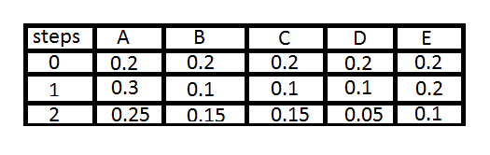
At 0th Step we have all Webpages PageRank values 0.2 that is 1/5 (1/n) . To get PageRank of Webpage A ,consider all the incoming links to A .So we have half the Page Rank of D is pointed to A and Full Rank of E is pointed to A . So it will be (1/5)*(1/2) + (1/5)*(1/1) which is (3/10) or 0.3 the Page Rank of A. Similarly the Page Rank of B will be (1/5)*(1/2) which is (1/10) or 0.1 because A's PageRank value is 1/5 or 0.2 from Step 0 . Even though we got 0.3 of A's PageRank in Step 1 we are considering 0.3 when we are Calculating Page Rank of B in Step 2.
The general rule is --> we consider (N-1)th step values when we are calculating the Page Rank values for Nth Step . Not Clear ? Please Comment it below .
In Similar way we calculate all the Page Rank Values and Sort them to Get the Most important Webpage to be displayed in the Search Results .

import java.util.*;
import java.io.*;
public class PageRank {

public int path[][] = new int[10][10];
public double pagerank[] = new double[10];

public void calc(double n)
{
double init;
double c=0;
double temp[] = new double[10];
int i,j,u=1,k=1;
init = 1/n;
System.out.printf(" n value:"+n+"\t init value :"+init+"\n");
for(i=1;i<=n;i++)
this.pagerank[i]=init;
System.out.printf("\n Initial PageRank Values , 0th Step \n");
for(i=1;i<=n;i++)
System.out.printf(" Page Rank of "+i+" is :\t"+this.pagerank[i]+"\n");

while(u<=2)
{
for(i=1;i<=n;i++)
{ temp[i]=this.pagerank[i];
this.pagerank[i]=0;
}

for(j=1;j<=n;j++)
for(i=1;i<=n;i++)
if(this.path[i][j] == 1)
{ k=1;c=0;
while(k<=n)
{
if(this.path[i][k] == 1 )
c=c+1;
k=k+1;
}
this.pagerank[j]=this.pagerank[j]+temp[i]*(1/c);
}

System.out.printf("\n After "+u+"th Step \n");
for(i=1;i<=n;i++)
System.out.printf(" Page Rank of "+i+" is :\t"+this.pagerank[i]+"\n");

u=u+1;
}
}
public static void main(String args[])
{
int nodes,i,j,cost;
Scanner in = new Scanner(System.in);
System.out.println("Enter the Number of WebPages \n");
nodes = in.nextInt();
PageRank p = new PageRank();
System.out.println("Enter the Adjacency Matrix with 1->PATH & 0->NO PATH Between two WebPages: \n");
for(i=1;i<=nodes;i++)
for(j=1;j<=nodes;j++)
{
p.path[i][j]=in.nextInt();
if(j==i)
p.path[i][j]=0;
}
p.calc(nodes);

}

}

